1. **Get Tenant ID from azure portal ,** click on user name in right upper corner , and check the guid for directory where AAD is residing:

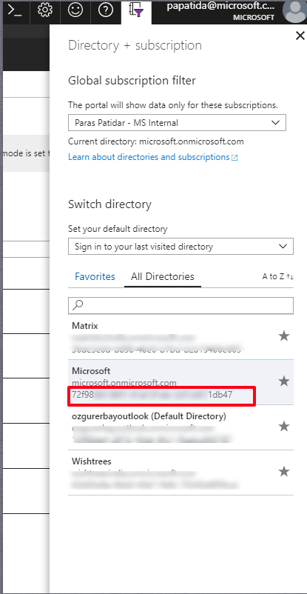

An AlterNet way is by using PowerShell and issuing Login-AzureRmAccount command :

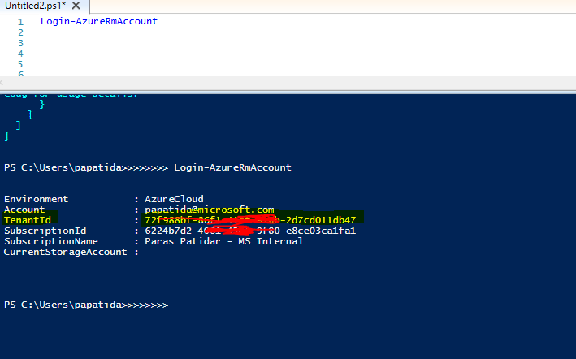

1. **Get the client ID & Client Secret :**
2. Open the AAD on Azure
3. Go to App registration option in blade.

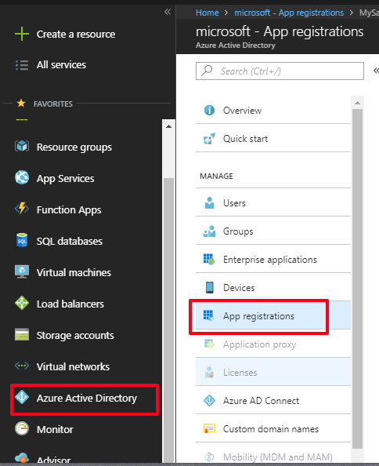

1. Select the AAD app for function app.
2. Click on settings
3. **Application Id is your Client ID**

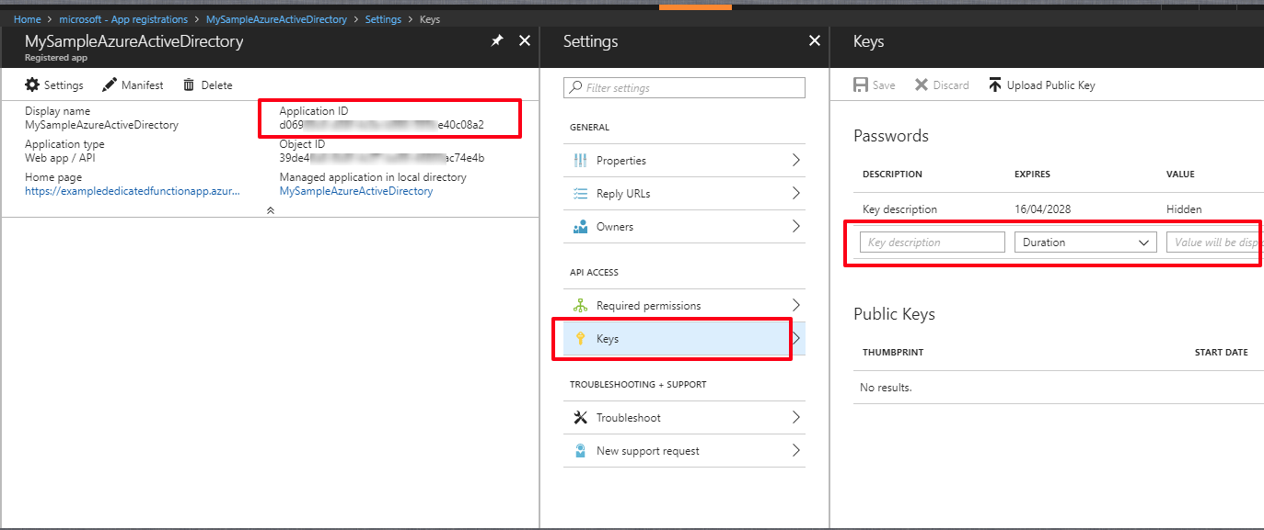

1. Select Keys option , type any key name and save to create new key , note down the key , it is your **client secret**

